1. *Outline of assignment*

For this assignment, we were required to build on the work done previously, when we researched machine learning packages, and chose two classification algorithms that we felt would appropriately deal with a given classification task. My choice of machine learning package was *scikit-learn*,

1. *Data preparation*

For both classification techniques, *scikit-learn* can recognise numeric data stored as numpy arrays or scipy sparse matrices. A number of tools are recommended for converting data into a format that scikit-learn can use, but given the simplicity of the data set, I opted to use NumPy’s [*genfromtxt*](https://docs.scipy.org/doc/numpy/reference/generated/numpy.genfromtxt.html) method, which was easily able to generate a numpy array from the training data.

The only other step required to prepare the dataset for reading by the *genfromtxt* method was to switch the columns and rows in the text file, as *genfromtxt* expects individual cases to be stored in rows, rather than columns. I achieved this by copying the contents of the *autoimmune.txt* file into an Excel workbook, which conveniently detects the tab delimiter used in the .txt file. At this point, I moved the row describing the Autoimmune_Disease feature to the bottom row of the dataset, to simplify the separation of data and target feature. I then **transposed this data (see steps below)** and saved it into a new tab delimited .txt file, called *autoimmune_transpose.txt*

**Steps for transposing:**

* *Starting point*

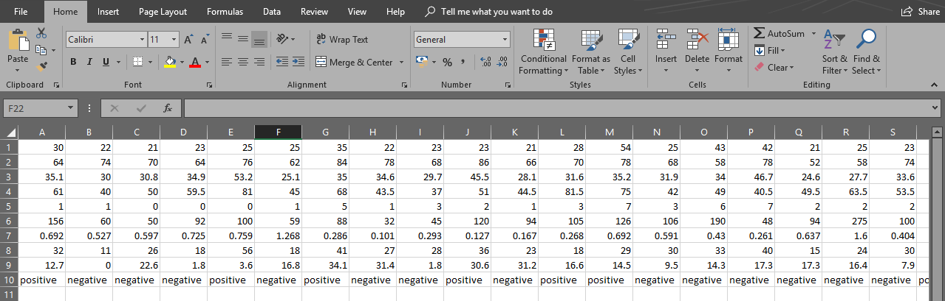

1. *Data preparation (continued)*

* Select the contents of the data for copying

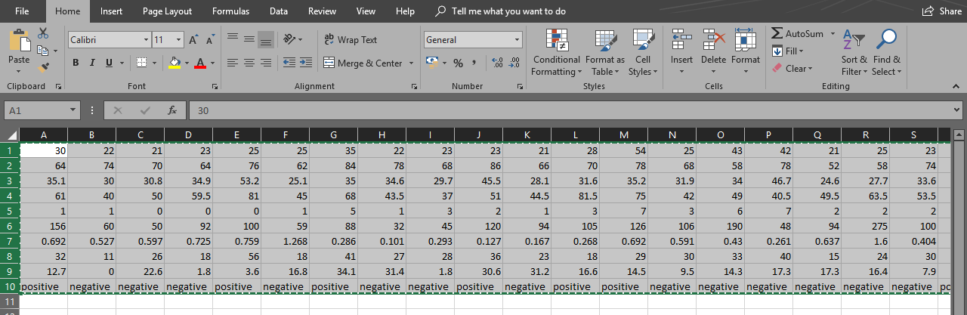

* Select some cell below the data, choose to paste ‘Transpose’

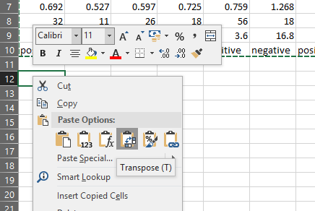

* Delete the original, un-transposed dataset, so only the transposed dataset remains

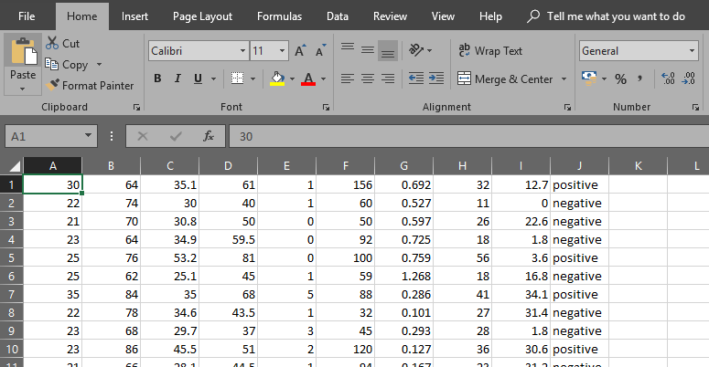

1. *Two classification algorithms applied*

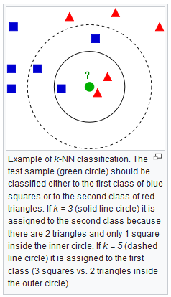The two classification algorithms that I chose for training classification models were *k-Nearest Neighbour (kNN),* which we covered in lectures, and *Support Vector Machines (SVM)*, which was mentioned in lectures, but not covered. As mentioned in Section 1, *scikit-learn* has classifier classes for both of these algorithms; [*kNeighborsClassifier*](http://scikit-learn.org/stable/modules/generated/sklearn.neighbors.KNeighborsClassifier.html#sklearn.neighbors.KNeighborsClassifier) and [*SVC*](http://scikit-learn.org/stable/modules/generated/sklearn.svm.SVC.html#sklearn.svm.SVC), respectively. Both algorithms construct models which are represented by points in space, and each model has its own way of classifying new samples.

**The k-Nearest Neighbours algorithm**

As described in lectures, the kNN algorithm operates by considering each sample to be a point in sample space. When a new sample is being queried, the algorithm finds the samples from the training data that are closest to it; specifically, it finds the *k* closest samples, or the *k nearest neighbours*. These neighbours then vote on the value of the new sample’s target feature (see diagram for example); in our case, they vote on whether the new sample should test *positive* or *negative* for Autoimmune Disease. This vote is based on a simple majority of the neighbours’ values of *Autoimmune_Disease*.

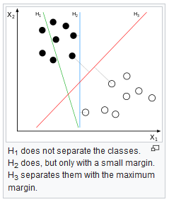

**The Support Vector Machines algorithm**

Like kNN, the SVM algorithm creates a model with each sample being a point in space. It then tries to create a *margin* in the space, which separates the samples that test *positive* for Autoimmune Disease from the samples that test *negative*. If the samples were 2-dimensional, for example, then SVM would essentially try to draw a line between the two groups of samples (see diagram). In our case, our samples have 9 attributes, so SVM aims to create an 8-dimensional hyperplane to separate the groups, called a *margin*. Then, when new samples are queried, SVM simply checks whether this query falls on the *positive* or *negative* side of this margin, and classes it accordingly. SVM strives to choose a margin with the largest possible gap between itself and any of the training data, to increase accuracy of future classifications.

1. *Estimation of performance by 10-fold cross validation*

*sci-kit learn* offers very straightforward functionality for performing cross-validation in the form of [*cross_val_score*](http://scikit-learn.org/stable/modules/generated/sklearn.model_selection.cross_val_score.html). We simply specify the classifier object (either a *kNeighborsClassifier* or *SVC* object in our case), and the training data and features to which that classifier is to be fitted. We may also specify the number of folds during the validation process, which should be *10* in our case. At each step, we get a validation score which scores the performance of the model. If we take the average of these scores, we get a sort-of overall performance score. The beauty of this is that scores can be compared, not only between models constructed by different algorithms, but also ones constructed by the same algorithm with different parameters.

1. *Estimation of performance by 10-fold cross validation (continued)*

For example, in the case of the **kNN model**, I was able to compare average scores across different values of *k*; specifically, I tested *k = 1, 2, …, 20*. The scores obtained for each value were:

*0.6861, 0.6943, 0.6917, 0.7262, 0.7288, 0.7421, 0.7501, 0.7636, 0.7529, 0.7421,   
0.7554, 0.7605, 0.7605, 0.7364, 0.7550, 0.7468, 0.7550, 0.7522, 0.7548*

From this, I could easily see that *k=8* generated the model with the highest cross-validation score. This would support the assertion that *k=8* would be the optimal choice when using the kNN algorithm to classify this dataset.

For the **SVM model**, although there were several optional parameters when declaring a classifier instance, trial and error showed that almost none of these affected the cross-validation score when changed. The one exception was the value of *gamma*, which could be set to either *‘scale’* or *‘auto’*. The scores obtained for each choice were *0.7424, 0.6863*, respectively, leading to the obvious conclusion that *‘scale’* was the better choice.

1. *Comparison of performance results between models*

If we compare the cross-validation scores obtained by the kNN and SVM models in their optimal setups (i.e., kNN using *k=8*, SVM using *gamma=’scale’*), we see that both algorithms give very similar results, with kNN outperforming SVM by only a small margin (scores were *0.7636* and *0.7424*, respectively).

[It is suggested](https://www.quora.com/What-is-better-k-nearest-neighbors-algorithm-k-NN-or-Support-Vector-Machine-SVM-classifier-Which-algorithm-is-mostly-used-practically-Which-algorithm-guarantees-reliable-detection-in-unpredictable-situations) that, in general, kNN is a better choice of algorithm if our dataset has a lot of points in a low dimensional space. Conversely, SVM may be the better choice for datasets with only a few points in a high dimensional space. Since the *autoimmune* dataset falls somewhere between those two categories, it stands to reason that the two algorithms should perform similarly.

*Bibliography*

[1] - [Scikit-learn: Machine Learning in Python](http://jmlr.csail.mit.edu/papers/v12/pedregosa11a.html), Pedregosa et al., JMLR 12, pp. 2825-2830, 2011.

[2] - *[Nearest Neighors](http://scikit-learn.org/stable/modules/neighbors.html#nearest-neighbors-classification)*, scikit-learn documentation (v0.20.0)

[3] - [*Support Vector Machines*](http://scikit-learn.org/stable/modules/svm.html#classification), scikit-learn documentation (v0.20.0)

[4] - [documentation](http://scikit-learn.org/stable/documentation.html), scikit-learn documentation (v0.20.0)

[5] - [*genfromtxt*](https://docs.scipy.org/doc/numpy/reference/generated/numpy.genfromtxt.html), NumPy documentation (v1.15)

[6] - [*kNeighborsClassifier*](http://scikit-learn.org/stable/modules/generated/sklearn.neighbors.KNeighborsClassifier.html#sklearn.neighbors.KNeighborsClassifier), scikit-learn documentation (v0.20.0)

[7] - [*SVC*](http://scikit-learn.org/stable/modules/generated/sklearn.svm.SVC.html#sklearn.svm.SVC), scikit-learn documentation (v0.20.0)

[8] - [*k-nearest neighbors algorithm*](https://en.wikipedia.org/wiki/K-nearest_neighbors_algorithm),Wikipedia

[9] - [*Support vector machine*](https://en.wikipedia.org/wiki/Support_vector_machine),Wikipedia

[10] - [*cross_val_score*](http://scikit-learn.org/stable/modules/generated/sklearn.model_selection.cross_val_score.html), scikit-learn documentation (v0.20.0)

[11] - [*What is better, k-nearest neighbors algorithm or Support Vector Machine classifier?*](https://www.quora.com/What-is-better-k-nearest-neighbors-algorithm-k-NN-or-Support-Vector-Machine-SVM-classifier-Which-algorithm-is-mostly-used-practically-Which-algorithm-guarantees-reliable-detection-in-unpredictable-situations), quora.org

*Code*

import numpy as np

import os

import matplotlib.pyplot as plt

from sklearn import neighbors, datasets, svm, ensemble

from sklearn.model_selection import cross_val_score

#change into location of dataset, specify file name

os.chdir('D:\\OneDrive - National University of Ireland, Galway\\NUIG\\2018-2019\\Semester 1\\CT475\\Assignment 1')

fname = 'autoimmune_transpose.txt'

#use np.genfromtxt to read in training data, and target feature data

autoimmune_data = np.genfromtxt(fname, delimiter='\t', encoding=None, usecols=np.arange(0,9))

autoimmune_target = np.genfromtxt(fname, delimiter='\t', dtype=None, encoding=None, usecols=9)

#create models with kNN, checking the the 10-fold cross validation scores for various values of k

k_scores=[]

for i in range(1,20):

kNN = neighbors.KNeighborsClassifier(i)

kNN_scores = cross_val_score(kNN, autoimmune_data, autoimmune_target, cv=10)

k_scores.append(kNN_scores.mean())

k_max = max(k_scores)

print("The highest 10-fold cross validation scores were found for k = ", k_scores.index(k_max)+1, ", which had a mean score of %.4f." % k_max, sep='')

#create models with SVM, checking the the 10-fold cross validation scores when gamma is set to 'scale' or 'auto'

s_scores=[]

s_options=['scale','auto']

for i in s_options:

svc = svm.SVC(gamma=i)

svc_scores = cross_val_score(svc, autoimmune_data, autoimmune_target, cv=10)

s_scores.append(svc_scores.mean())

s_max = max(s_scores)

print("The highest 10-fold cross validation scores were found when gamma was set to '", s_options[s_scores.index(s_max)], "', which had a mean score of %.4f." % s_max, sep='')

if k_max >= s_max:

print("A higher mean cross validation score was obtained by the kNN algorithm.")

else:

print("A higher mean cross validation score was obtained by the SVM algorithm.")